Explorers’ Summer 2 Newsletter
Dear Parents,
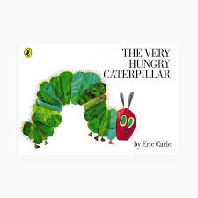This half term our Mini Adventure is all about ‘Lifecycles’. We will be exploring the lifecycle of a butterfly, frog and a sunflower through a range of stories and engaging and exciting activities. We will be planting seeds and looking at them as they grow and change. We are going to collect some frogspawn from our wonderful school pond that has been recently revamped. This will enable the children to observe the changes over time and talk about and record what they see. The children will be encouraged to communicate what they see using a range of scientific language and vocabulary.
Lots of our learning will take place outdoors in the school grounds and we hope for lots of warm, dry weather. To help us keep your children safe in the sun can you please ensure they come to school with sunscreen protection on every day. The children are welcome to bring extra cream in their bag but they will need to apply it themselves. Please can you also ensure your child has a named sun hat or cap to wear too.
Reception Homework – Your support at home is invaluable and really helps your child. We recommend that in order to support their learning children in Reception should read their school book at home for about 10 minutes every day, and then spend a further 5 minutes practising their words and sounds. Please can parents ensure that the Reception children bring their book bag to school every day. From this week the children will also have a weekly spelling activity to complete. This will come home on Thursday, so look out for the extra file in the bag!
If you have any questions or queries please come and see us!
The Explorers Team
Sophea Pounder, Joanne Murray, Sarah Hunter, Jane White & Lewis

Throughout this term we will be baking and cooking, the children really enjoy this and learn lots too!
To help with the cost we are asking for a contribution of £3 per child towards the ingredients.
____________________________________________________________________
Reply Slip
I enclose £3 to help towards the cost of cooking ingredients for the term.

Child’s Name__________________________

