Maths | Communication, Language and Literacy
To count forwards and backwards to 20.  Know that I can count anything.  To recognise and write the numerals to 10.  To accurately count out a given number of objects.  To select the correct numeral to represent a given number of objects.  To use the language of more and fewer to compare sets of objects.  To record using marks and numerals that I can interpret and explain.  To identify, name, sort and describe 2D shapes and talk about some of the properties. | To listen to stories with increasing attention and recall.  To describe main story events, settings and characters.  To begin to blend and segment simple sounds.  To recognise half of the phase 2 phonemes.  To read at least 15 of the phase 2 words.  To write at least 10 of the phase 2 words.  To talk about and recount my experiences.  To write simple labels and captions with support.  To sequence stories and rhymes using pictures.  To respond to the instructions given.  To use talk to connect ideas, explain what is happening and anticipate what might happen next.
Understanding the World - Science | Expressive Arts and Design – Exploring and Using Media and Materials
To observe and name a variety of sources of sound, noticing that we hear with our ears.  To identify, name and label the basic parts of the human body.  To know the importance of good health and know that exercise and healthy eating are important.  To observe changes in the seasons as we move from summer to Autumn. | To use line, shape and colour with effect when drawing and painting.  To select and use tools for a specific purpose.  To explore combining materials to create different effects.  To explore levers and winding mechanisms.
Understanding the World - Technology | Expressive Arts and Design – Being Imaginative
To login to the computer using my username and password.  To use the keyboard to type.  To create a picture using simple tools on 2 Paint. | To introduce a storyline or narrative into their play.  To engage in role-play and use available props to support role play.  To choose particular colours for a purpose.  To create stories using objects.
Understanding the World – Geography | Expressive Arts and Design - Music
To make comments and ask questions about where I live.  To look closely at the seasonal changes from Summer to Autumn.  To name the countries in the UK.  To remember and talk about significant events in my life. | To sing a variety of simple songs and rhymes.  To explore how Sounds can be made and changed.  To tap out simple repeated rhythms.  To use a variety of instruments to make loud, quiet, long and short sounds.
Religious Education | Physical Development
To understand that the word God is a name.  To understand that Christians believe God is the Creator of the universe.  To understand that Christians believe God made our world and that we need to look after it. | To move with confidence in a variety of ways and move and stop on command.  To move in response to music and other stimuli.  To use one handed tools and equipment with more independence.  To be independent when getting myself changed for PE and Swimming.
Personal, Social and Emotional Development | Spiritual, Moral and Cultural Development
To be confident to try new activities.  To show I am aware of the boundaries and behavioural expectations within the Explorers Zone. | To use our hands in kind and helpful ways.  To show I enjoy learning about myself and others.  To respect the feelings and views of others.
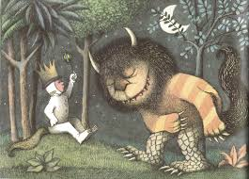

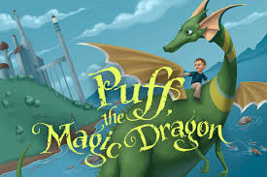

Time to Shine
CLL
To describe my Fantastic Beast using amazing adjectives and create simple sentences.

EAD
To design and create my own ‘Fantastic Beast’ using a variety of mediums and materials.

Fantastic
Beasts
UTW
To communicate and demonstrate my knowledge of healthy eating through my explanation of the food wheel.

Reception

Maths
To demonstrate my knowledge of 2D shapes and their properties.

