Summer 1 – 2016/17
Can you write a thank you letter, a report and a poem?
English
Maths  - I can find 1000 more or less than a given number.  - I can count backwards through zero to include negative numbers.  - I can identify, represent and estimate numbers using different representations.  - I can identify right angles, recognise that two right angles make a half-turn, three make three quarters of a turn and four a complete turn; recognise and name obtuse and acute.  - I can use formal written methods of multiplication and division.  - I can complete a coin card grid for multiplication. | Writing for a purpose  Writing reviews, character descriptions and also writing persuasive arguments that debate Toad’s guilt.  - Compose and rehearse sentences orally.  - Use alliteration effectively.  - Use similes effectively.  - Use a range of descriptive phrases including some collective nouns.  - Place the possessive apostrophe accurately in words with regular plurals (for example, girls’, boys’) and in words with irregular plurals (for example, children’s).
Science  - I can identify and name a variety of common animals that are birds, fish, amphibians, reptiles, mammals and invertebrates.  - I can name and classify a variety of common animals that are carnivores, herbivores and omnivores.  - I can recognise that soils are made from rocks and organic matter (Keyhole Garden) | Reading  - I can explain and discuss understanding of reading, maintaining focus on the topic.  - I can draw inferences such as inferring characters’ feelings, thoughts and motives from their actions, and justifying inferences with evidence.
Religious Education  Leaders of religion  - I can describe similarities and differences in the teachings and prastices of Christianity and Islam in relation to the Christian value of friendship. | Computing – Logo  - I can use sequence, selection, and repetition in programs; work with variables and various forms of input and output  - I can use logical reasoning to explain how some simple algorithms work and to detect and correct errors in algorithms and programs
Languages
- I can give responses to questions about every day events.
I can name some animals and pets in French
PHSCE  Living in the wider world  - Through a class trial, I can demonstrate my understanding of how rules and laws are needed and enforced and how they protect me and others. | History  To build an understanding of world history  - I can describe the changes to the river and our use of the river over time.
Forest Skills  • I can show an ability to both lead and form part of a team.  • I can support others and seek support if required when the situation dictates. | PE – Tennis with Mrs Burroughs  - I can strike the ball using a racket.  - I can strategically place my shots to make it harder for the opposition.
Design Technology  Materials  - I can choose suitable techniques to construct products or to repair items.  - I can create a circuit to motorise my design.  To design, make and evaluate  - I can design and work with care to ensure my product is fit for purpose. | Music  Singing with Ms Smith  - I can sing from memory with developing control of pitch.  - I can maintain a simple part within a group  - I can sing and move in time with songs from other cultures.  Selecting the soundtrack to accompany Wind in the Willows.  - I can use the terms: duration, timbre, pitch, beat, tempo, texture and use of silence to describe music.
Art  Textiles (continued from last Mini Adventure)  • I can plan, create and evaluate a cross stitch bookmark for my new Bible.  The children will also be using a range of printing, collage and painting techniques to participate in two art competitions. | Geography  To investigate places  I can use fieldwork to observe and record the human and physical features in the local area using a range of methods including sketch maps, plans and graphs and digital technologies.
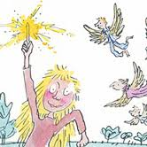

Wind in the Willows
A study of the characters in Kenneth Grahame’s classic novel.
I can debate Toad’s innocence/guilt in the class courtroom
Writing/Reading
I can design and make a motorised boat that meets the specifications.
DT?Science
I can design intricate patterns using ‘Logo’.
Maths/Computing
I can present my specialist knowledge of my chosen animal.
Science
Time to Shine
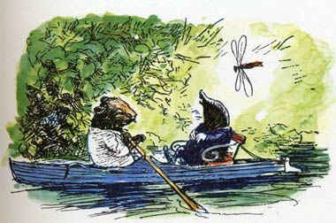
I can record changes at different points along the river.
Geography/Science
Time to Shine

