 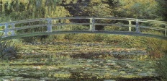  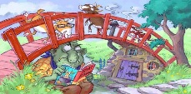

**Time to Shine**

alter

I can select tools, materials and mediums to create a collage.

EAD

I can choose my own Time to Shine challenge.

I can make a bridge.

STEM

I can show increasing control of an object.

PD

I can recite and perform a rhyme.

CLL

**Over the Bridge**

**Nursery**