Maths | Literacy
I can reason and solve one step problems and missing number problems that involve addition, subtraction, multiplication and division by using objects, pictorial representations and arrays.  I can count, read and write numbers from 1-100 in numerals and words.  I can recognise and know the value of different denominations of coins and notes.  I know my learn Its to step 6.  I can confidently identify, name and talk about the properties of 2D and 3D shapes.  I can learn the 10x table. | I can read a variety of texts and be confident to answer a variety of questions about what I have read.  STEM/Computing  I can make a variety of 2D and 3D shapes using various materials.  Research/Science  I can research, find, identify, name, draw and write about a variety of plants and trees.  I can spell all of the year 1 common exception words and the first 100 high frequency words consistently and accurately in my writing.  I can use a range of punctuation including full stops, capital letters, exclamation marks, question marks and speech marks where appropriate in my writing.  I can use noun phrases and adverbs to add interest and extra detail to my writing.  I can write a letter and address an envelope correctly.  I can use Jack and The Beanstalk as inspiration for my own writing.
Science | Design and Technology
I can identify and name a variety of common plants, including garden plants, wild plants and trees.  I can identify and describe the basic structure of a variety of common flowering plants, including roots, stem/trunk, leaves and flowers.  I can observe how seeds and bulbs grow into mature plants. | I can research a variety of instruments and investigate what they are made out of.  I can design and make a musical instrument.  I can make simple levers and winding mechanisms.
History/Geography | Art and Design
I can use artefacts, pictures, stories and online sources to investigate and interpret Castles in the past.  I can use books, pictures and atlases to find out about castles around the world and can identify similarities and differences. | I can investigate printing with a variety of natural and man-made materials and objects.  I can press, roll, rub and stamp to make prints.  I can make a simple printing block and use it to print.
Computing | Music
I can control motion by specifying the number of steps to travel, direction and turn – 2 Go and Logo.  I can use digital media and use a range of tools to create different textures, lines, tones, colours and shapes. | I can create a mixture of long, short, loud, quiet, high and low sounds.  I can sequence sounds to create an overall effect.  I can create short, musical patterns and rhythmic phrases.
Religious Education | Physical Development
I know what it means to belong and to be part of a community.  I know what it means for a Christian to belong to a church and to be part of a religious family.  I know some ways that Christians give expression to belonging to such a family and why.  I have some understanding of baptism, confirmation and marriage. | I can throw and catch a variety of balls, bean bags etc.  I can negotiate the space around me when playing racing and chasing games with more accuracy.  I can adjust my speed or change direction to avoid obstacles.  I can use rolling, hitting, running, jumping, catching and kicking skills in combination.
Personal, Social and Emotional Development | Spiritual, Moral and Cultural Development
I can recognise and celebrate my strengths and set simple but challenging goals. | I can recognise the differences between right and wrong and respect the views of others.
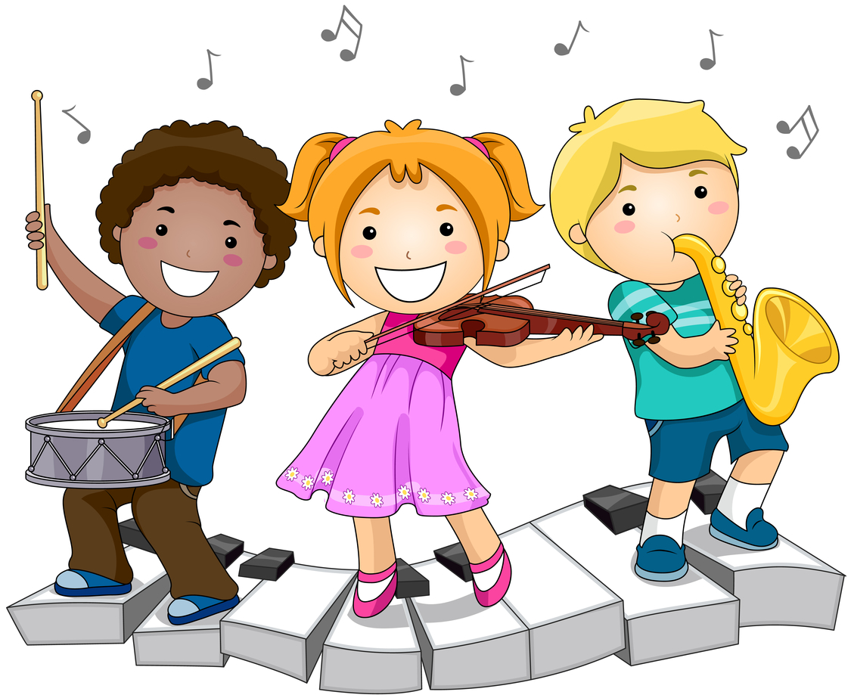

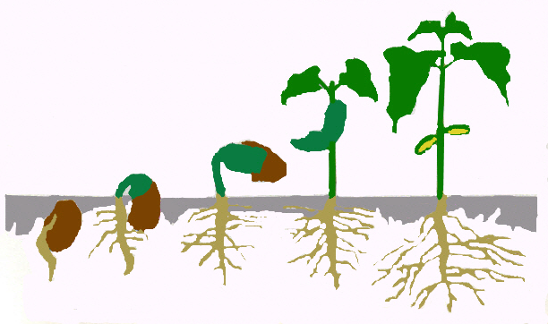
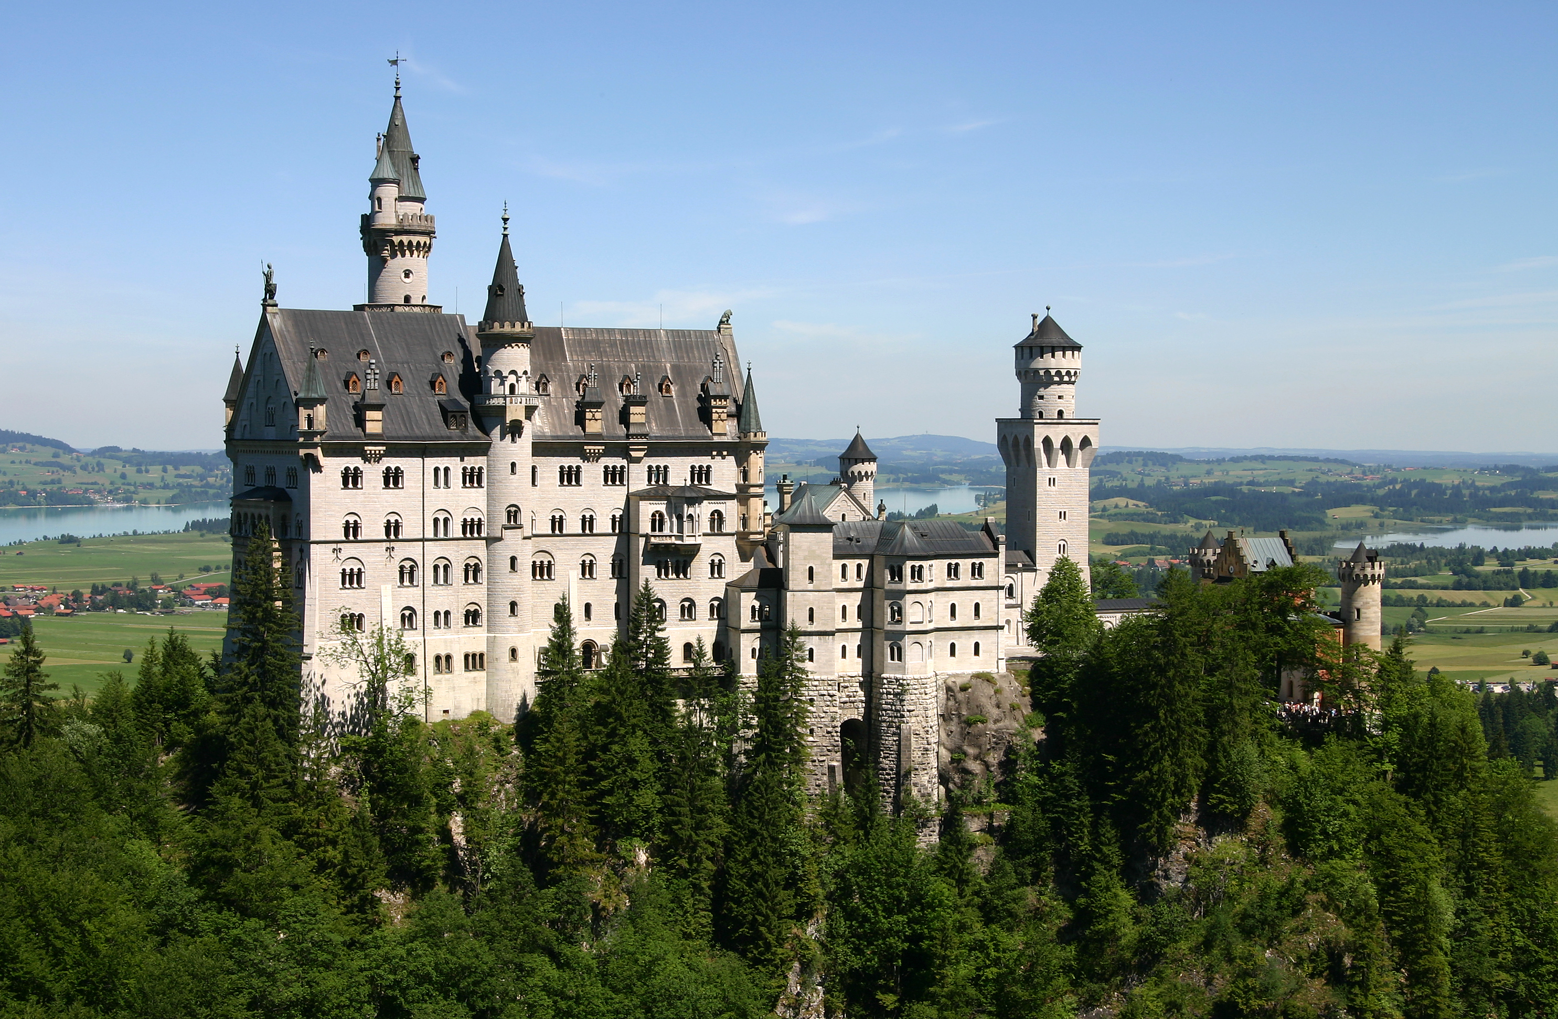
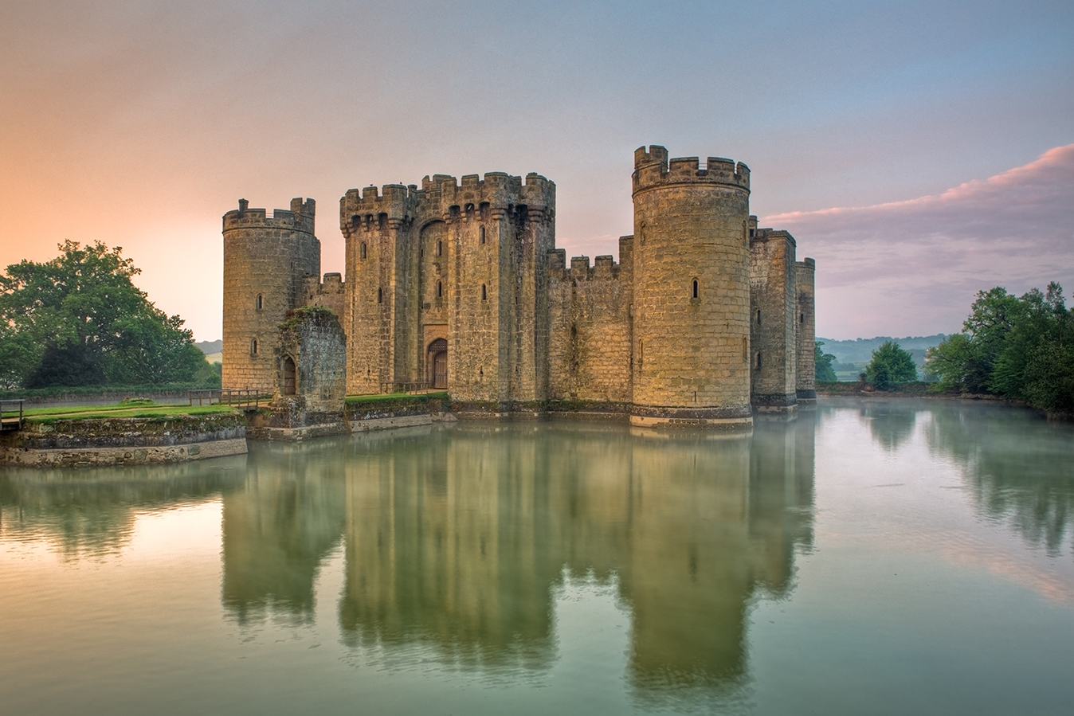
Time to Shine
Year 1
Castles
Literacy
I can write a letter and address and envelope correctly.

Creative
I can design and make a musical instrument using reclaimed materials.

Seocan Long

