Maths | Communication, Language and Literacy
I can count reliably to 20 forwards and backwards and match the correct number of objects.  I can place the numbers 1-20 in order.  I can say which number is 1 more/less than a given number to 20.  I can count in 10s.  I can begin to solve simple addition and subtraction problems involving 2 single digit numbers.  I can explore doubling and halving.  I can talk about some of the properties of 2D and 3D shapes. | I can recognise all of the phase 2 and half of the phase 3 phonemes.  I can read and write all of the phase 2 words and some of the phase 3 words.  I can be more consistent at using full stops and capital letters in my sentence writing.  I can be more confident to use my phonic knowledge to decode more complex words independently when reading and writing.  I can read and understand simple sentences and talk about what I have read.  I can use Jack and the Beanstalk as inspiration for writing.
Knowledge of the World - Science | Expressive Arts and Design – Exploring and Using Media and Materials
I can talk about what a plant needs to grow.  I can name and label the parts of flowers, plants and trees.  I can talk about similarities and differences in plants. | I can print with a variety of materials and objects.  I can make a simple printing block and use it to print.  I can select and use resources, simple tools and techniques competently and appropriately.  I can select the tools and techniques I need to shape, assemble and join the materials I am using.
Knowledge of the World - Technology | Expressive Arts and Design – Being Imaginative
I can begin to control motion by counting steps to travel in different directions and make turns.  I am beginning to use digital media and use a range of tools to create different textures, lines, tones, colours and shapes. | I am confident to introduce a story or narrative into my play.  I can represent my own ideas, thoughts and feelings through design and technology, art, music role play and stories.
Knowledge of the World – Geography/History | Expressive Arts and Design - Music
I can use books, pictures, stories and online sources to investigate Castles.  I can identify and name castles from their picture. | I can make and control long, short, loud, quiet, high and low sounds using voices and instruments.  I can make imitate changes in pitch  I can sing a variety of songs and rhymes and experiment with ways to change them.
Religious Education | Physical Development
I am beginning to understand what it means to belong and to be part of a community.  I have a basic understanding that Christians belong to a church and that they are part of a religious family.  I have a basic understanding of baptism, confirmation and marriage. | I can throw and catch a variety of objects with increased accuracy.  I can begin to negotiate the space around me when playing racing and chasing games.  I can begin to adjust my speed or change direction to avoid obstacles.  I can use a pencil and hold it effectively to form lower case letters using the correct formation and orientation.
Personal, Social and Emotional Development | Spiritual, Moral and Cultural Development
I can recognise and celebrate my strengths and set simple but challenging goals. | I can recognise the differences between right and wrong and respect the views of others.
Time to Shine
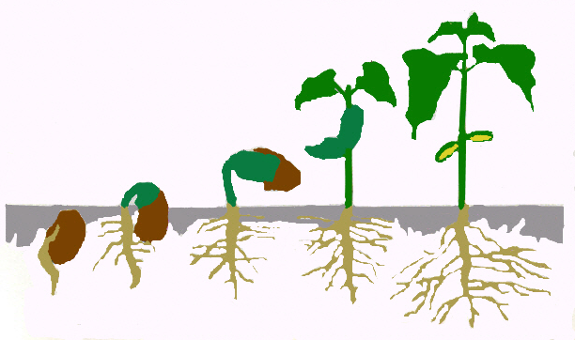
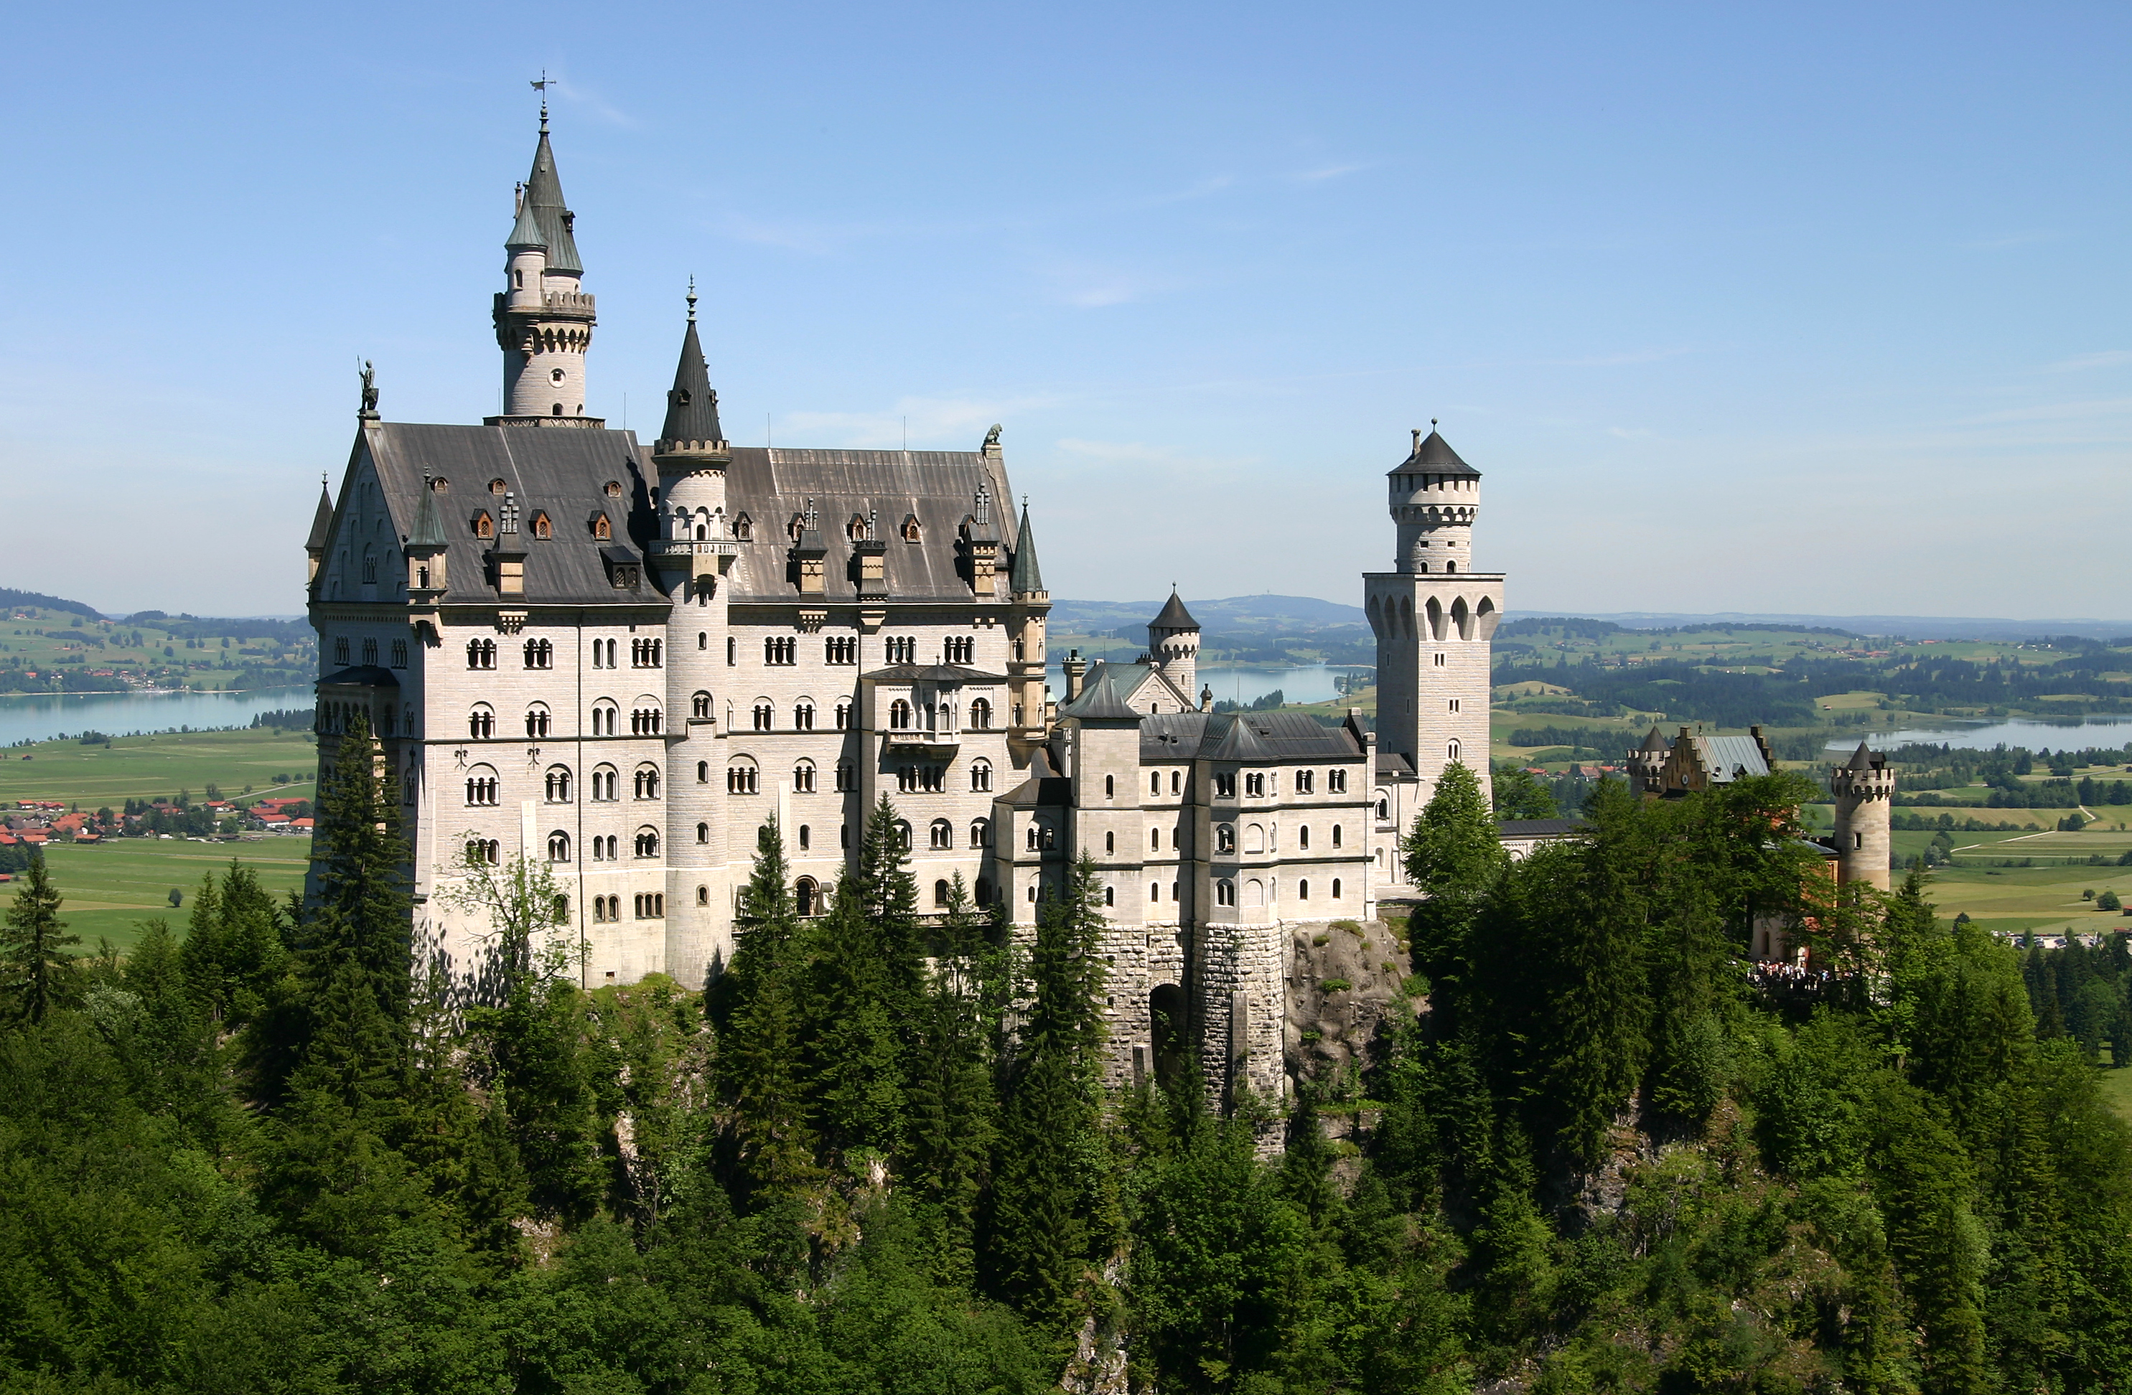
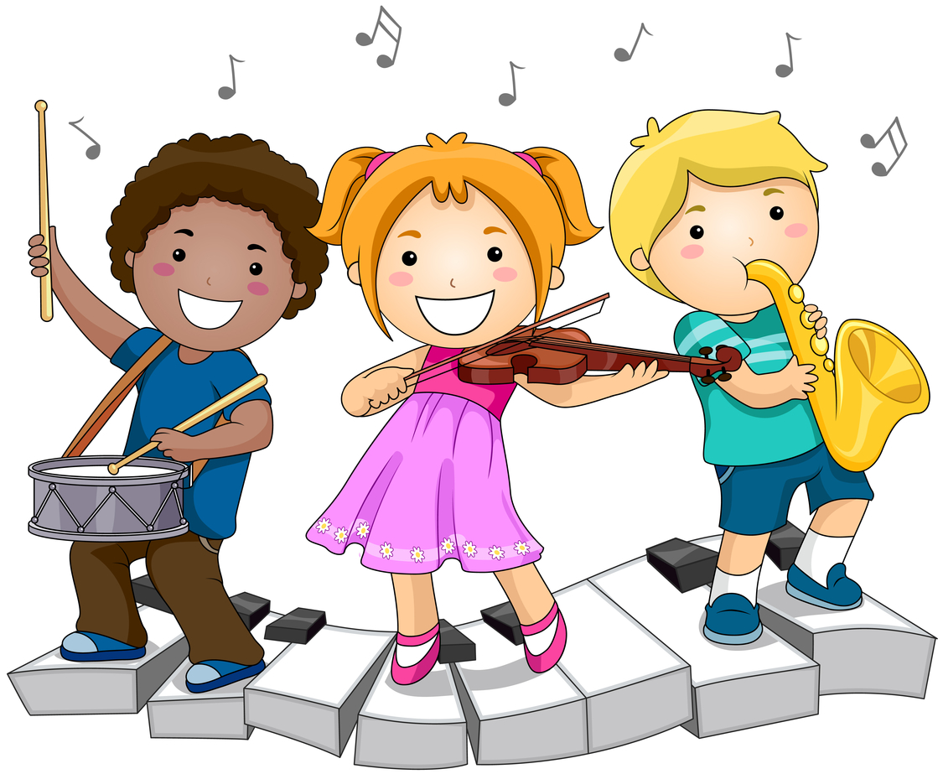
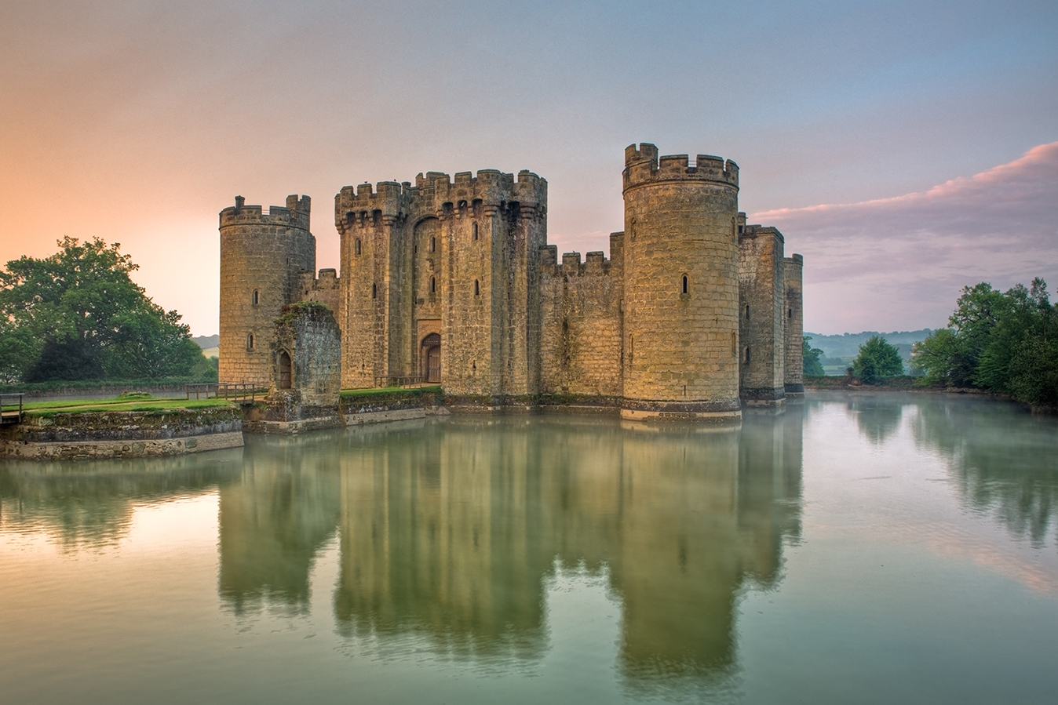

Research/Computing
I can find out how plants grow and record my findings.

Creative
I can design and make a musical instrument.

Reception
Castles
DT & Maths
I can make a variety of 2D and 3D shapes.

Literacy
I can write a simple story with a beginning, middle and end.

