Maths | Literacy
I can write the numbers and number words to 100.  I can reason and solve a variety of mathematical problems involving addition, subtraction, multiplication and division by calculating the answer using objects and pictorial representations.  I can find half and quarter of a shape, object or quantity.  I can confidently count in multiples of 2’s, 5’s and 10’s.  I know and use number bonds and related subtraction facts, confidently within 20 and relate this to larger numbers.  I can partition a 2 digit number.  I can measure and record length and height in cms. | I can begin to use the prefix un.  I can design and make bridge with a moving part.  STEM  I can create a mini fact book about ‘Bridges from around the World’.  Research/Computingng  I can begin to use apostrophes to contract some words eg: didn’t, I’m, couldn’t, can’t etc.  I can write using bullet points and numbered steps.  I can create non-fiction fact sheets about bridges.  I can write stories using the language of traditional tales and add detail to make my writing more interesting.  I can begin to use noun phrases and adverbs to add extra detail.  I can experiment with rhyming words and create simple poems.
Science | Art and Design
I can find out how the shapes of solid objects can be changed by squashing, bending, twisting and stretching.  I can investigate to find about changes in materials when they are heated and cooled.  I can investigate building bridges out of a variety of materials to see which is the strongest. | I can use a combination of shapes.  I can use rolled up paper, straws, paper and card to create.  I can use watercolours effectively.  I can use coloured pencils to show different tones.  I can explore ideas and collect pictures of bridges.
History/Geography | Design and Technology
I can find out about Isambard Kingdom Brunel and some of his amazing work through artefacts, pictures, stories and online sources.  I can create a bridge timeline.  I can find out about historic bridges in the UK.  I can use books, pictures and atlases to find out about bridges in the UK and around the world and can identify similarities and differences. | I can demonstrate a range of joining techniques (such as gluing, hinges or combining materials to strengthen).  I can measure and mark out to the nearest cm.  I can investigate and create products using levers, wheels and winding mechanisms.  I can use tools and equipment to cut, shape, join and finish.  I can build bridges using a variety of materials and explore how to make them stronger, stiffer and more stable.
Computing | Music
I can use safe search engines to find out about bridges.  I can use the Ipad to take photos and create a Picollage.  I can control motion by specifying the number of steps to travel, direction and turn. | I can identify some Classical tracks and its composer.  I can talk about how the music makes me feel.  I can move in response to the music and adjust my bodies movements according to the tempo and melody.
Religious Education | Physical Development
I know that Easter is important to Christians because it celebrates the resurrection of Jesus.  I know that Easter is a special and happy time involving special stories, events and traditions, although it is preceded by a solemn time when Christians prepare for and reflect on the crucifixion of Jesus.  I know that the Bible is the main source for information  about Jesus’ crucifixion and resurrection. | I can copy and remember actions.  I can link two or more actions together to make a sequence.  I can travel by rolling forwards and sideways.  I can hold a position whilst balancing on different points of the body.  I can jump in a variety of ways and land correctly with increasing control and balance.
Personal, Social and Emotional Development | Spiritual, Moral and Cultural Development
I can respect myself and others and know the importance of responsible behaviours and actions. | I can use my imagination and creativity in my learning.  I can reflect on my experiences.
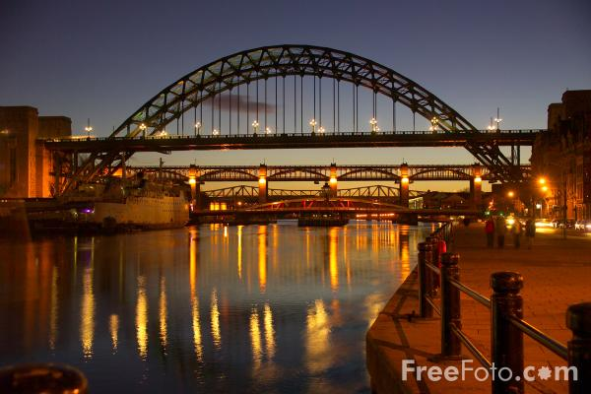
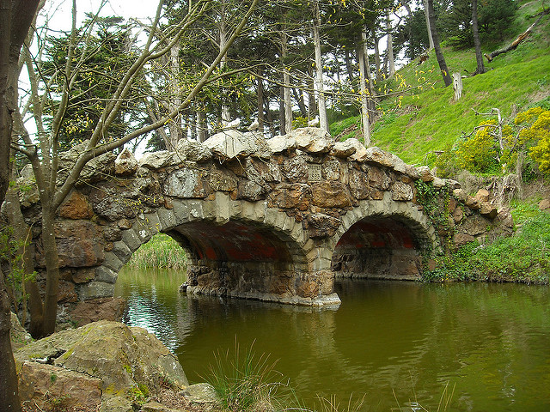
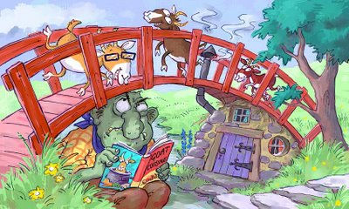
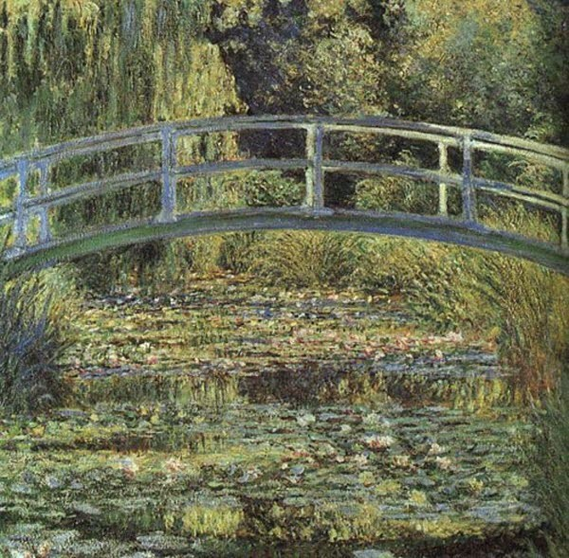
Time to Shine
Year 1
Over The Bridge
I can learn a poem or rhyme and perform in front of an audience.
Literacy
I can create pictures of bridges using a variety of art techniques.
Creative

I can choose my own ‘Time to Shine’ challenge.

