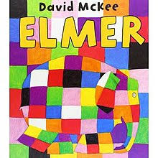 Explorers’ Spring 2 Newsletter 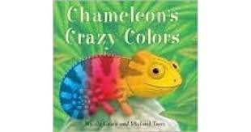
Dear Parents,
This half term our Mini Adventure is all about ‘Colours’. We will be exploring the colours in our World and we will be inspiring the children in the beginning with the Elmer stories. We have lots of exciting colour exploration activities planned which focus on the areas of Expressive Arts and Design and Understanding the World as well as linking into all of the other areas of learning too. In Communication, Language and Literacy we are focussing on communicating to others in small groups then to larger audiences. We will also be encouraging the children to use their descriptive skills to describe a variety of objects using amazing adjectives and this is something you can do at home too. As you will see from the Maths Time to Shine we are focusing on Capacity and Measure, this is also an area that you can help and support your child with at home when cooking, baking, talking about the size of objects and what they might measure/hold. We will introduce the children to standard measures, however it’s really important that they understand that we can measure with anything, pencils, teddys etc. The bath is a great place to explore the capacity of different containers and you can talk about full, half full, empty, more, less etc. Have fun!!
Reception Homework – Your support at home is invaluable and really helps your child. We recommend that in order to support their learning children in Reception should read their school book at home for about 10 minutes every day, and then spend a further 5 minutes practising their words and sounds. Please can parents ensure that the Reception children bring their book bag to school every day. In the next couple of weeks your child will come home with a word writing activity. Please read the letter in the folder as this will explain the activity in more detail.
Important Dates for your Diary
Friday 8th March we will be taking part in our annual Poetry Recital
Tuesday 12th March we will be having an Open Morning for Nursery and Reception parents. This session will enable you to come and join your child in their learning, have some fun and enjoy a variety of activities.
Tuesday 19th and Thursday 21st March - Parents Consultations for Nursery and Reception parents
On Tuesday 26th March visit to Seven Stories. If your child is not normally in on this day we would love them to join us. A letter with further details will be following soon.

If you have any questions or queries please come and see us!
The Explorers Team
Sophea Pounder, Joanne Murray, Sarah Hunter, Jane White & Lewis

