Maths | Communication, Language and Literacy
I can count forwards and backwards to 20 and can recognise and write most of the numbers involved.  I can combine groups of objects together to make a total.  I can take objects away from a group and say how many I have left and solve simple calculations.  I know my number bonds to 10.  I can solve simple number problems.  I can count in 10s.  I am confident to use a range of positional language.  I am confident to talk about the properties of 2D and 3D shapes. | I can recognise all of the phase 2 and some of the phase 3 phonemes.  I can read and write all of the phase 2 words.  I can be more confident to segment and blend the sounds I know to help me read and write simple words.  I can write a simple sentence.  I can continue and generate simple rhyming strings.  I know that a sentence has a capital letter and a full stop and can begin to show this in my writing.  I can use simple adjectives in my sentences to make them more exciting.  I can use talk to organise, sequence and clarify my thinking.
Knowledge of the World - Science | Expressive Arts and Design – Exploring and Using Media and Materials
I can find out how the shapes of solid objects can be changed by squashing, bending, twisting and stretching.  I can investigate to find about changes in materials when they are heated and cooled.  I can investigate building bridges out of a variety of materials to see which is the strongest. | I can explore ideas and collect pictures of bridges.  I understand that different media can be combined to create new effects.  I can construct bridges using a variety of mediums and materials.  I can select the tools and techniques needed to shape, assesmble and join the materials I am using.
Knowledge of the World - Technology | Expressive Arts and Design – Being Imaginative
I can use the Ipad to take photos.  I can use safe search engines to find pictures of bridges . | I can create simple representations of bridges.  I can choose to use particular colours for a purpose.  I can perform a variety of rhymes and poems for a variety of audiences.
Knowledge of the World – Geography/History | Expressive Arts and Design - Music
I can find out about Isambard Kingdom Brunel and some of his amazing work through artefacts, pictures, stories and online sources.  I can use books, pictures and atlases to find out about bridges in the UK and around the world, and talk about how they are the same/different. | I can identify some Classical tracks and its composer.  I can talk about how the music makes me feel.  I can move in response to the music and adjust my bodies movements according to the tempo and melody.
Religious Education | Physical Development
I know that Easter is important to Christians because it celebrates the resurrection of Jesus.  I know that Easter is a special and happy time involving special stories, events and traditions, although it is preceded by a solemn time when Christians prepare for and reflect on the crucifixion of Jesus.  I know that I can use the Bible to find information  about Jesus’ crucifixion and resurrection. | I can copy and remember actions.  I can link two or more actions together to make a sequence.  I can travel by rolling forwards and sideways.  I can hold a position whilst balancing on different points of the body.  I can jump in a variety of ways and land correctly with increasing control and balance.
Personal, Social and Emotional Development | Spiritual, Moral and Cultural Development
I can respect myself and others and know the importance of responsible behaviours and actions. | I can use my imagination and creativity in my learning.  I can reflect on my experiences.
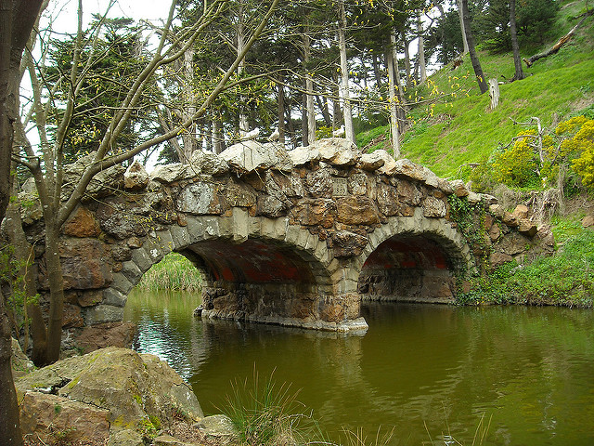
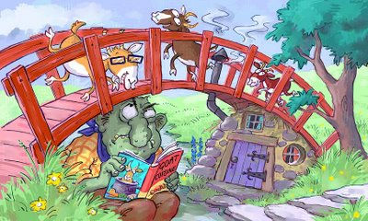
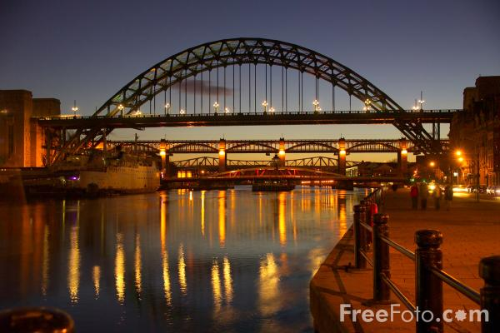
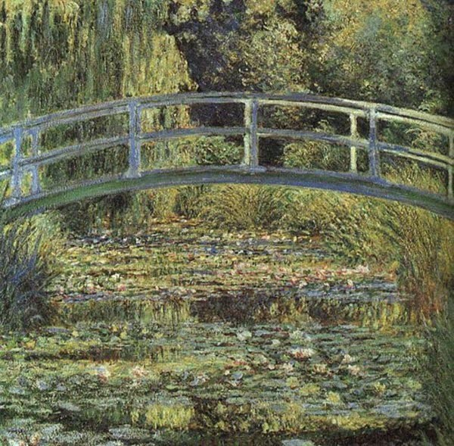
Time to Shine
I can help to create information pages about ‘Bridges from around the World’
Literacy/Computing
I can design and make a bridge.
STEM
Reception
Over The Bridge
I can perform a poem to an audience.
CLL
I can create a picture of a bridge.
Creative

I can choose my own ‘Time to Shine’ challenge.

