Explorers’ Spring 2 Newsletter
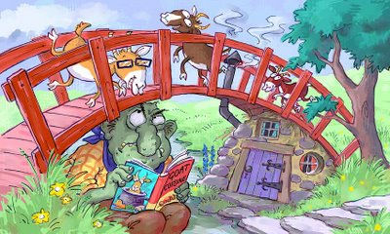
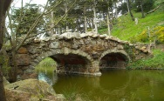
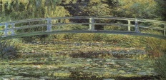
Dear Parents,
We hope you all had a lovely half term. This week we will start our new Mini Adventure – Over the Bridge. As the title suggests we are going to be learning about bridges. We will be looking into the history of bridges and how they have been built over time. We will also be finding out about famous bridges from around the world. The children will also be designing and making their own bridges using a wide variety of mediums and materials. Your child’s new Mini Adventure Plan is attached to this letter. To incorporate the children’s ideas we have decided to let them have input into one of their ‘Time to Shine Challenges’. This will be chosen by the child after discussions with a member of staff. This will then be added to their Learning Journey.
The Nursery children will have an outdoor Physical Development session on Tuesday morning; this session will focus on a range of gross motor skills. The Reception and Year 1 children will have PE on a Monday morning. Our focus this half term is gymnastics. Please can you ensure that all the Reception and Year 1 children have their named PE kit in school at all times as we may do PE at other times in addition to this session.
On a Thursday morning the Nursery children will continue to take part in Outdoor Forest Based Learning. The Reception and Year 1 children will continue to do Outdoor Learning on a Friday afternoon. Please remember to ensure your child has suitable clothing in school for these sessions.
Homework – Thank you for your ongoing support in helping your child at home. Your support is invaluable and really helps your child. We recommend that in order to support the their learning children in Reception should read their school book at home for at least 5 minutes every day, and then spend a further 5 minutes practising their words and sounds. Once in year 1, children should be reading their books, discussing the text and practising words and sounds for about 15/20 minutes a day. The Year 1 children will continue to get weekly spellings; these are sent home on a Thursday and need to be completed by the following Wednesday morning.

We have a few important events this half term and look forward to welcoming The Explorers’ parents in school.
Poetry Recital - Friday 3rd March (Nursery, Reception & Yr1 parents)
Numeracy Morning – Tuesday 21st March (Reception & Yr1 parents)
Nursery Open Morning – Tuesday 4th April (Nursery Parents)
The Explorers’ Team
Sophea Pounder, Karen Fender, Joanne Murray, Jane White & Sarah Hunter

