Maths | Literacy
Count to and across 100 forwards and backwards and read and write numbers in numerals and words.  Count in multiples of 2s, 5s and 10s.  Solve one step problems involving multiplication and division using concrete objects and pictorial representations and arrays with support.  Recognise, find and name half and quarter of a shape, object or quantity.  Identify and represent numbers, objects and pictorial representations including the number line and use the language of equal to, more/less than, most and least.  Represent and use number bonds and related subtraction facts within 20.  Add and subtract one and two digit numbers using concrete objects, pictorial representations and mentally. | Know the 40+ phonemes and some of the alternative spelling patterns – Phase 2-5 sounds off by heart.  Spell the year 1 common exception words confidently.  Add s and es as the plurals for nouns.  Add the prefix un where there is no change to the root word.  Identify and use some compound words when reading and writing.  Use a range of punctuation accurately and consistently – full stops, capital letters, question marks and exclamation marks when writing.  Show some awareness of speech marks and begin to use these when writing to show when someone is speaking.  Write known stories in own words, then change settings, characters and storyline using known story structures.  Check that writing makes sense by re-reading and then making changes where appropriate.  Read a wide range of texts with intonation and increased fluency.  Talk about what they characters are thinking and feeling.
Science | Art and Design
Talk about what makes a fair test.  Investigate to find out which materials/objects float and sink and which are waterproof / non-waterproof.  Look at how materials change when they are heated and cooled. | Mix primary colours to make secondary colours.  Use techniques such as rolling, cutting, moulding and carving.  Observe and draw a variety of objects, use lines of different sizes and thickness and show pattern and texture by adding dots and lines.
History / Geography | Design and Technology
Look at different versions of ‘The Gingerbread Man’ story over time to compare and contrast different versions.  Explore and find out where the water in rivers starts from and where they end up. | Demonstrate a range of joining techniques (such as gluing, hinges or combining materials to strengthen).  Create products using levers, wheels and winding mechanisms.  Refining the design as work progresses and suggest improvements to them.
Computing | Music
Control when drawings appear and set the pen colour, size and shape.  Control motion by specifying the number of steps to travel, direction and turn.  Use a word processing programme to type information in sentences. | Use instruments to create sounds to link with the story ‘The Gingerbread Man’  Listen to a variety of music and use appropriate musical vocabulary to describe it.  Identify some of the different elements of music and how they affect mood and style.
Religious Education | Physical Development
Look at the Christian festival of Pentecost.  Explore some aspects of the Jewish faith and compare this to Christianity.  Talk about some of the aspects of the Jewish faith. | Use a variety of balls, ben bags, rackets and hockey sticks with increased control and skill.  Move with careful control and coordination.  Move with some control and awareness of space.
Personal, Social and Emotional Development | Spiritual, Moral and Cultural Development
Recognise and celebrate my strengths and set simple but challenging goals. | Recognise the differences between right and wrong and respect the views of others.
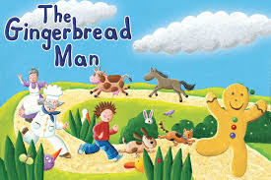
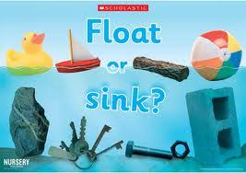
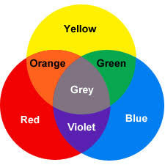
Time to Shine
My Mini Adventure

Literacy & Computing
Write a ‘Snowy Lands’ story with a beginning, middle and an end and create a front cover for the story using 2 Paint.

Science & Maths
Investigate to find how far the Snow Mobiles travel and measure the distance in metres and cm’s.

Computing
Use a word processing programme to create a picture and sentences linked to the story of ‘The Gingerbread Man’.

STEM
Design and make a product that will help the Gingerbread Man get across, over or under the river.

Year 1

The Gingerbread
Man
Physical Development
Demonstrate physical control and skill development when using a variety of PE equipment such as balls, bean bags, rackets and hockey sticks.
Literacy
Demonstrate /show understanding of the story ‘The Gingerbread Man’ and create own story by changing settings and characters of the story.

