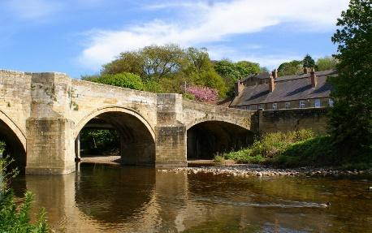
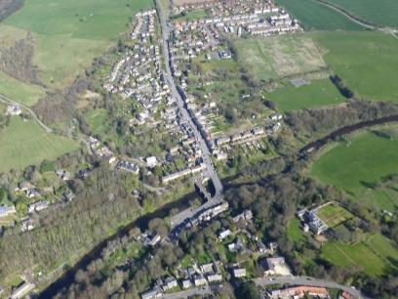
Felton:
A Village Through Time…

Mini Adventure ∙Spring 1 2019 ∙ Pioneers

Writing | Reading | Mathematics | Geography
Plan, draft, write, edit and improve.  Use the techniques that authors use to create characters, settings and plots.  Create vivid images by using alliteration, similes, metaphors and personification.  Interweave descriptions of characters, settings and atmosphere with dialogue.  Write sentences that include relative pronouns.  Write sentences that include hypens, colons and semi colons.  Use semi-colons, colons or dashes to mark boundaries between independent clauses.  Use a colon to introduce a list. | Draw inferences such as inferring characters’ feelings, thoughts and motives from their actions, and justifying inferences with evidence.  Discuss and evaluate how authors use language, including figurative language, considering the impact on the reader.  Provide reasoned justifications for views. | Identify, name and write equivalent fractions  Read and write decimal numbers as fractions.  Use common factors to simplify fractions  Associate a fraction with division and calculate decimal fraction equivalents.  Add and subtract fractions with the same denominator and denominators that are multiples of the same number.  Add and subtract fractions with different denominators and mixed numbers, using the concept of equivalent fractions.  Multiply proper fractions and mixed numbers by whole numbers, supported by materials and diagrams.  Multiply simple pairs of proper fractions, writing the answer in its simplest form.  Divide proper fractions by whole numbers.  Find fractions of amounts | Collect and analyse statistics and other information in order to draw clear conclusions about locations.  Identify and describe how the physical features affect the human activity within a location.  Use a range of geographical resources to give detailed descriptions and opinions of the characteristic features of a location.  Use different types of fieldwork sampling (random and systematic) to observe, measure and record the human and physical features in the local area. Record the results in a range of ways.  Analyse and give views on the effectiveness of different geographical representations of a location (such as aerial images compared with maps and topological maps.  Create maps of locations identifying patterns (such as: land use, climate zones, population densities, height of land).
Key Text(s):
Tom’s Midnight Garden – Phillipa Pearce
The Secret Garden (extracts of) – Frances Hodgson Burnett
Northumberland -Strange but True - Robert Woodhouse

Computing | Science | PSHCE | Physical Education
Understand and demonstrate knowledge that it is illegal to download copyrighted material, including music or games, without express written permission, from the copyright holder.  Choose the most suitable applications and devices for the purposes of communication.  Use many of the advanced features in order to create high quality, professional or efficient communications.  Select appropriate applications to devise, construct and manipulate data and present it in an effective and professional manner. | Plan enquiries, including recognising and controlling variables where necessary.  Take measurements, using a range of scientific equipment, with increasing accuracy and precision.  Record data and results of increasing complexity using scientific diagrams and labels, classification keys, tables, bar and line graphs, and models.  Present findings in written form, displays and other presentations.  Understand how some materials will dissolve in liquid to form a solution and describe how to recover a substance from a solution. | Identify what positively and negatively affects their physical, mental and emotional health  Reflect on and celebrate their achievements, identify their strengths, areas for improvement, set high aspirations and goals.  Deepen their understanding of good and not so good feelings, to extend their vocabulary to enable them to explain both the range and intensity of their feelings to others.  Recognise that they may experience conflicting emotions and when they might need to listen to their emotions or overcome them.  Discuss change, including transitions between schools | Compose creative and imaginative dance sequences.  Perform expressively and hold a precise and strong body posture.  Perform and create complex sequences.  Express an idea in original and imaginative ways.  Plan to perform with high energy, slow grace or other themes and maintain this throughout a piece.  Perform complex moves that combine strength and stamina gained through gymnastics activities (such as cartwheels or handstands).

Art and Design | Religious Education | Music | Languages
Develop and imaginatively extend ideas from starting points throughout the curriculum.  Collect information, sketches and resources and present ideas imaginatively in a sketch book.  Spot the potential in unexpected results as work progresses.  Comment on artworks with a fluent grasp of visual language.  Sketch (lightly) before painting to combine line and colour.  Use the qualities of watercolour and acrylic paints to create visually interesting pieces.  Use brush techniques and the qualities of paint to create texture.  Develop a personal style of painting, drawing upon ideas from other artists.  Give details (including own sketches) about the style of some notable artists  Create original pieces that show a range of influences and styles. | Explain how some teachings and beliefs are shared between religions.  Explain how religious beliefs shape the lives of individuals and communities.  Show an understanding of the role of a spiritual leader.  Recognise and express feelings about their own identities. Relate these to religious beliefs or teachings.  Show an awareness of morals and right and wrong beyond rules (i.e. wanting to act in a certain way despite rules). | Perform solos or as part of an ensemble.  Perform with controlled breathing (voice) and skillful playing (instrument).  Use the standard musical notation of crotchet, minim and semibreve to indicate how many beats to play.  Read and create notes on the musical stave.  Use and understand simple time signatures. | Read and understand the main points and some of the detail in short written texts.  Show confidence in reading aloud, and in using reference materials.  Take part in conversations to seek and give information.  Refer to recent experiences or future plans, everyday activities and interests.
Key Artist
Friedensreich Hundertwasser

Trips/visits
Field studies (mapping activities, land-use data collection, history walks etc) within the local area, as and when is required throughout the half term.

Time to Shine!
Can you create your own artistic representation of the local area, using painters we have studied as inspiration?
Can you inform and guide visitors to Felton using your knowledge of maps and data?
Can you create a digital guided history tour of Felton?

