Maths | Communication, Language and Literacy
Count forwards and backwards to 50, recognise and write the numbers involved.  Combine groups of objects together to make a total.  Take objects away from a group and say how many are left.  Use the language associated with addition and subtraction.  Complete simple addition and subtraction calculations.  Solve simple addition and subtraction problems.  Learn the number bonds to 10.  Order 4 or 5 items by length or height.  Recognise, find and name a half as one of two equal parts of an object, shape or quantity.  Explore measure using non-standard units.  Create a simple pictogram. | Explain knowledge and understanding of ideas and concepts from mini adventure and ask appropriate questions of others.  Listen to stories, accurately anticipating key events.  Explain and discuss understanding of texts both fiction and nonfiction  Link statements and stick to a main theme or intention.  Express ideas effectively, showing an awareness of the listener’s needs.  Develop narratives and explanations by connecting ideas or events.  Recognise all of the phase 2 and at least half of the phase 3 sounds.  Read at least 30 of the first 100 words independently.  Be confident to segment and blend known sounds to both read and write words independently  Create simple sentence(s)using a full stop at the end.
Understanding the World - Science | Expressive Arts and Design – Exploring and Using Media and Materials
Carry out an investigation to see which snow mobile travels the furthest.  Identify and name a variety of common animals that are found in Snowy places and talk about some of them.  Investigate changing materials – freezing and melting. | Explore crayon resist and foil painting to create winter pictures.  Use, sort and arrange a combination of materials that are cut, torn and glued and mix materials to create different textures.  Use clay and techniques such as rolling, cutting, moulding and carving to create an animal that lives in Snowy lands.
Understanding the World - Computing | Expressive Arts and Design – Being Imaginative
Log on to Purple Mash.  Use a range of tools to control when drawings appear and set the pen colour, size and shape. | Create simple representations of events, people and objects.  Choose particular colours to use for a purpose.  Represent Bible stories through art, music, dance and role play.
Understanding the World – History/Geography | Expressive Arts and Design - Music
Use artefacts, pictures, stories, online sources and databases to find out about famous Polar Explorers.  Recount changes that have occurred in their own lives.  Devise a simple map; and use and construct basic symbols in a key. Use simple grid references (A1, B1). | Create a mixture of different sounds (long and short, loud and quiet, high and low) and choose sounds to create an effect.  Listen to a variety of music and use appropriate musical vocabulary to describe it.  Paint in response to a variety of music.
Religious Education | Physical Development
Listen to, recall, and talk about stories from the Bible with a focus on developing an understanding of some of the Christian values and how they might demonstrate these in their own lives at school and at home.  Use art, music, dance and role play and writing to convey the Bible stories. | Dance Focus based on Snowy Lands  Move with careful control and coordination  Copy and remember moves and positions.  Link two or more actions to perform a sequence.  Choose movements to communicate a mood, feeling or idea.
Personal, Social and Emotional Development | Spiritual, Moral and Cultural Development
Demonstrate confidence and resilience when trying new activities that are more challenging.  Speak with confidence in a familiar group and talk about their ideas.  Choose the resources needed for an activity  Relate my learning to The Awareness Animals. | Demonstrate willing ness to ‘have a go’, take a risk, engage in new experiences and learn by trial and error.  Persevere with an activity when challenges occur.  Reflect on my experiences using pictures and words.  Use my imagination and creativity in my learning.  Talk about my feelings and reflect learning both socially and academically
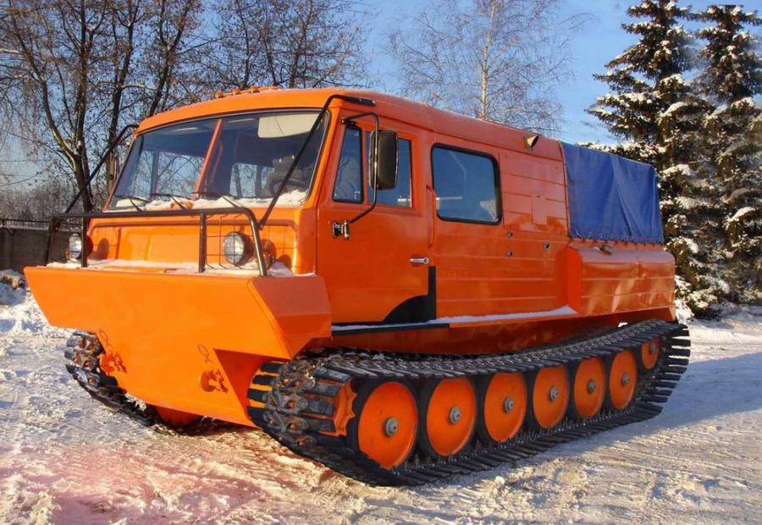
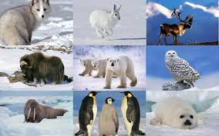
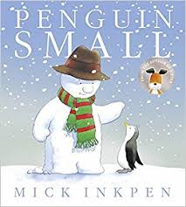
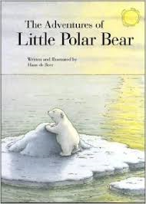

Time to Shine
Science DT & Maths
Design and build Snow Mobiles and then plan a way to measure how far they travel.

Literacy
Create/write a simple story set in Snowy Lands.

Snowy
Lands
Art and Design
Create an amazing picture of an arctic animal in its habitat using a variety of self- chosen mediums and materials.

Reception

CLL & RE
Retell a Bible story with a friend to others in my own words using simple props.

