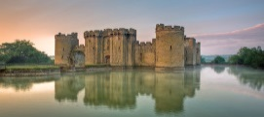 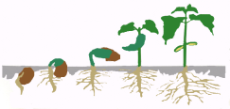 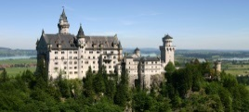

**Time to Shine**

alter

I can find the resources, tools and equipment I need to carry out an independent task and tidy up.

PSED

I can ask significant questions and talk about a lifecycle.

CLL & UW

I can use 2D and 3D shapes to construct a castle.

Maths/EAD

I can use a variety of tools and techniques to create a musical instrument.

PD/EAD

I can listen to and follow instructions.

PSED/CL

**Castles**

**Nursery**