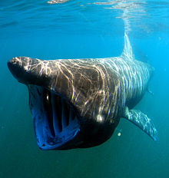
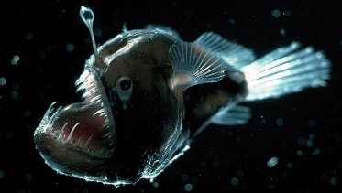
What’s down there?

Mini Adventure ∙Autumn 2018 ∙ Pioneers

Writing | Reading | Mathematics | Science
Choose the appropriate form of writing using the main features identified in reading.  Guide the reader by using a range of organisational devices, including a range of connectives.  Choose effective grammar and punctuation.  Write paragraphs that make sense if read alone.  Write cohesively at length.  Write sentences that include brackets.  Distinguish between homophones and other words that are often confused.  Using expanded noun phrases to convey complicated information concisely.  Using relative clauses beginning with who, which, where, when, whose, that or with an implied (i.e. omitted) relative pronoun. | Summarise the main ideas drawn from more than one paragraph, identifying key details that support the main ideas.  Retrieve and record information from non-fiction.  Provide reasoned justifications for views. | Solve problems involving addition, subtraction, multiplication and division and a combination of these, including understanding the meaning of the equals sign.  Use knowledge of the order of operations to carry out calculations involving the four operations.  Multiply using the formal written method of long multiplication.  Divide formal written method of long division  Divide using the formal written method of short division where appropriate, interpreting remainders according to the context. | Describe how living things are classified into broad groups according to common observable characteristics.  Give reasons for classifying plants and animals based on specific characteristics.  Recognise that living things have changed over time and that fossils provide information about living things that inhabited the Earth millions of years ago.  Recognise that living things produce offspring of the same kind, but normally offspring vary and are not identical to their parents.  Identify how animals and plants are adapted to suit their environment in different ways and that adaptation may lead to evolution.
Computing | Geography | PSHCE | Physical Education
Collaborate with others online on sites approved and moderated by teachers.  Give examples of the risks of online communities and demonstrate knowledge of how to minimise risk and report problems. | Collect and analyse statistics and other information in order to draw clear conclusions about locations.  Use a range of geographical resources to give detailed descriptions and opinions of the characteristic features of a location.  Name and locate some of the countries and cities of the world and their identifying human and physical characteristics, including hills, mountains, rivers, key topographical features and land-use patterns; and understand how some of these aspects have changed over time.  Describe geographical diversity across the world. | Deepen their understanding of good and not so good feelings, to extend their vocabulary to enable them to explain both the range and intensity of their feelings to others.  Recognise that they may experience conflicting emotions and when they might need to listen to their emotions or overcome them. | Create complex and well-executed sequences that include a full range of movements including: travelling, balances, swinging, springing, flight, vaults, inversions, rotations, bending, twisting, stretching, gestures and linking skills.  •Hold shapes that are strong, fluent and expressive.  Include in a sequence set pieces, choosing the most appropriate linking elements.  Vary speed, direction, level and body rotation during floor performances.  Practise and refine the gymnastic techniques used in performances (listed above).  Demonstrate good kinesthetic awareness (placement and alignment of body parts is usually good in well-rehearsed actions).
Religious Education | Music | Languages
Explain how some teachings and beliefs are shared between religions.  Explain how religious beliefs shape the lives of individuals and communities.  Explain the practices and lifestyles involved in belonging to a faith community.  Explain some of the different ways that individuals show their beliefs.  Explain their own ideas about the answers to ultimate questions.  Explain why their own answers to ultimate questions may differ from those of others. | • Hold a part within a round.  • Sustain a drone or a melodic ostinato to accompany singing.  • Use the standard musical notation of crotchet, minim and semibreve to indicate how many beats to play.  • Read and create notes on the musical stave. | • Refer to recent experiences or future plans, as well as to everyday activities.  • Convey meaning (although there may be some mistakes, the meaning can be understood with little or no difficulty).  • Understand the main points and opinions in spoken passages.  • Refer to recent experiences or future plans, everyday activities and interests.

Time to Shine!
Using your knowledge of evolution, adaptation and the world’s oceans, can you create your own marine creature?

