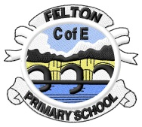Adventurers’ Spring Newsletter

From Grunts to Tweets

Welcome back! I hope you have had an amazing break and are ready to begin our first Mini-Adventure of 2017. This term we explore how storytellers have passed on information for centuries, sometimes through the spoken word and sometimes through writing. From the grunts of the Palaeolithic era, to the travelling poets of the Iron Age, we will investigate how and why changes to our language exist and also how our means of recording have developed to include the latest technology.

**PE on Wednesday**

In our PE this half term, we will be exploring rhythms through dance. Please can all children bring and leave their PE kit as soon as possible

**Outdoor Learning**

This term we are heading outdoors every Friday afternoon. Please ensure that your child has appropriate clothing. Children are permitted to come to school in their outdoor clothing, provided that they are wearing their purple school jumper/cardigan.

As always, if at any point in the term you have anything you wish to discuss, please arrange an appointment through Mr Long.

Many thanks

Richard Pearson