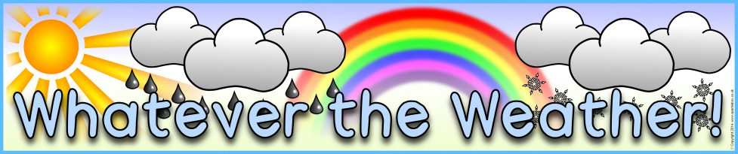
Spring 2019
Writing | Reading | Mathematics | Geography
• Write for a variety of purposes.  • Use some of the characteristic features of the type of writing used.  • Use well-chosen adjectives.  • Organise writing in line with its purpose.  • Group related information.  • Join sentences with conjunctions and connectives.  • Vary the way sentences begin.  • Begin to punctuate using a capital letter for the name of people, places, the days of the week and I.  • Use sentences with different forms: statement, question, exclamation and command.  • Use subordination (when, if, that or because).  • Use coordination (or, and, but).  • Read aloud writing with some intonation. | • Read accurately by blending sounds in unfamiliar words containing GPCs that have been taught.  • Read words with contractions (for example, I’m, I’ll, we’ll) and understand that the apostrophe represents the omitted letter(s).  • Read words containing common suffixes.  • Read most words quickly and accurately, without overt sounding and blending, when they have been frequently encountered.  • Re-read books to build up fluency and confidence in word reading.  • Check that reading makes sense and self-correct.  • Infer what characters are like from actions.  • Explain and discuss understanding of texts.  • Make inferences on the basis of what is being said and done. | • Given a number, identify one more and one less.  • Count in steps of 2, 3, 5 and 10 from 0 or 1 and in tens from any number, forward and backward.  • Compare and order numbers from 0 up to 100; use <, > and = signs.  • Recognise the place value of each digit in a two-digit number (tens, ones).  • Add and subtract a two-digit number and ones.  • Add and subtract a two-digit number and tens.  • Adding three one-digit numbers.  • Recall and use addition and subtraction facts to 20 fluently, and derive and use related facts up to 100.  • Calculate mathematical statements for multiplication and division within the multiplication tables and write them using the multiplication (x), division (÷) and equals (=) signs.  • Show that multiplication of two numbers can be done in any order (commutative) and division of one number by another cannot.  • Solve problems involving multiplication and division using mental methods.  • Use standard units to estimate and measure length/height (m/cm); mass (kg/g); temperature (°C); capacity (litres/ml) to the nearest appropriate unit, using rulers, scales, thermometers and measuring vessels.  • Compare and order lengths, mass, volume/capacity and record the results | • Ask and answer geographical questions (such as: What is this place like? What or who will I see in this place? What do people do in this place?).  • Use world maps, atlases and globes to identify the United Kingdom and its countries, as well as the countries, continents and oceans studied.  • Name, locate and identify characteristics of the four countries and capital cities of the United Kingdom and its surrounding seas.  • Name and locate the world’s continents and oceans.  • Understand geographical similarities and differences through studying the human and physical geography of a small area of the United Kingdom and of a contrasting non-European country.  • Identify seasonal and daily weather patterns in the United Kingdom and the location of hot and cold areas of the world in relation to the Equator and the North and South Poles.  • Use basic geographical vocabulary to refer to: key physical features, including: beach, coast, forest, hill, mountain, ocean, river, soil, valley, vegetation and weather.  • Use compass directions (north, south, east and west) and locational language (e.g. near and far) to describe the location of features and routes on a map.
Computing | Science | Physical Education | Art and Design
• Control motion by specifying the number of steps to travel, direction and turn.  • Add text strings, show and hide objects and change the features of an object.  • Select sounds and control when they are heard, their duration and volume. | • Ask simple questions.  • Perform simple tests.  • Use observations and ideas to suggest answers to questions.  • Observe the apparent movement of the Sun during the day.  • Observe changes across the four seasons.  • Observe and describe weather associated with the seasons and how day length varies. | • Copy and remember moves and positions.  • Move with careful control and coordination.  • Link two or more actions to perform a sequence.  • Choose movements to communicate a mood, feeling or idea. | • Explore ideas and collect visual information.  • Use a combination of materials that are cut, torn and glued.  • Sort and arrange materials.  • Mix materials to create texture.  • Describe the work of notable artists, artisans and designers.  • Use some of the ideas of artists studied to create pieces.
Design and Technology | Music | Languages | Religious Education
• Cut materials safely using tools provided.  • Measure and mark out to the nearest centimetre.  • Demonstrate a range of cutting and shaping techniques (such as tearing, cutting, folding and curling). | • Make and control long and short sounds, using voice and instruments.  • Create a sequence of long and short sounds.  • Clap rhythms.  • Use symbols to represent a composition and use them to help with a performance. | • Write or copy everyday words correctly.  • Label items and choose appropriate words to complete short sentences.  • Understand a range of spoken phrases.  • Identify countries and communities where the language is spoken. | • Describe some of the teachings of a religion.  • Describe some of the main festivals or celebrations of a religion.
PHSCE | Forest Based Learning
• Recognise what they like and dislike, how to make real, informed choices that improve their physical and emotional health, to recognise that choices can have good and not so good consequences.  • Recognise that they share a responsibility for keeping themselves and others safe, when to say, ‘yes’, ‘no’, ‘I’ll ask’ and ‘I’ll tell’.  • Communicate their feelings to others, to recognise how others show feelings and how to respond.  • Recognise how their behaviour affects other people. | • Develop leadership and teamwork skills during collaborative tasks.  • Identify changes in the outdoor environment.

Time to Shine Challenges
Persuade tourists to visit your chosen holiday destination
Inform the people about the upcoming weather (in English or in French)
Create a piece of body of work to represent a chosen season

