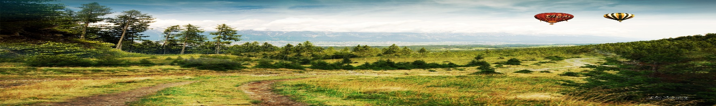
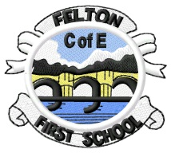
Voyagers Autumn Newsletter

Welcome back to school!

I am delighted to have the privilege of teaching and working with your children!
The children have had a super start to this new academic year. We have already focused on Fairy Tales and the children have been using parts of their own favourite stories, to create an entirely new one.
As year 3 and 4 are a newly formed class, I thought a new journey theme would be very fitting for us all.
To launch our first journey we will be releasing balloons with the school contact details on them. I wonder how far our balloons will reach?
Our first mini adventure will be based on the classic tale “Journey to the Centre of the Earth”, written by Jules Verne (1864).
We will be unpicking the text (like authors) and discovering the amazing ideas and inventions he had. This will lead us to inventions that have changed our lives. We will also take a journey into the core of our planet, learning about the structure and formation of the Earth.

Reading and Spelling
The children will have the opportunity to change their reading books during guided reading throughout the week. I will run guided reading sessions in small groups where your children will be encouraged to articulate and record their responses to texts, in particular focussing on interpreting their ideas from the clues in texts (inference skills). Please encourage your children to read independently every day and whilst the children are now mostly fluent readers, it is still important to hear them read at least once a week.
In addition to our class text we will be reading a book called “Brightstorm” by Vashti Hardy. This is a wonderful story about a set of twins who go on a sky ship adventure.
In school, we will also follow a daily spelling session, focussed on developing reading and spelling word families, pre-fixes and suffixes. Spellings sent home each week are tailored lists designed to address any spelling weaknesses identified from the curriculum word lists the children were tested on at the end of last year.

Homework
Homework will be sent home in homework books every Friday, to be returned to me by Thursday. Spellings will be tested on Thursdays. The children will also bring home a Big Maths Beat That (BMBT) and CLIC homework sheet. The BMBT is a timed challenge, where the children solve the calculations facts as fast as they can. The CLIC sheet challenges the children to complete the calculations by applying the core calculation facts that they know. The children will also complete the BMBT and CLIC challenges in class every Thursday. If your child consistently completes the BMBT challenges in the allotted time, they will progress to the next step. If your child gets 10 out of 10 twice on their CLIC, they will move up to the next step.
I have also included a Homework Menu sheet. These challenges are based on the theme of the mini adventure.
The children do not need to complete all of them across the term but they must do at least 3. They are craft and DT based so that the children can use their other skills.

PE and The Felton Mile
Mrs Burrows will be leading PE sessions for the children on Wednesday mornings this year. Please make sure your child has clothing suitable for both indoor and outdoor sessions. As you know, we will be continuing our Wednesday morning “Felton Mile”, so please ensure that your child comes to school in PE kit on Wednesday mornings, bringing school uniform to get changed into after PE.

Friday Forest Skills
On Friday we’re always excited for Outdoor Learning in the afternoon, so children need to wear/bring:
- Warm trousers, in line with school uniform colours (ones that can get dirty)
- Warm socks/ welly socks
- A change of footwear (walking boots or wellies)
- Layered tops – t-shirts/long sleeved tops/jumpers (we do ask children still wear their school jumper or cardigan as their top layer)
- The school will provide waterproof coats and trousers

Thank you for all the wonderful craft donations, we are very grateful!

If you have any questions or concerns please let me know.

Mrs Paisley

