**Explorers’ Spring 1 Newsletter**

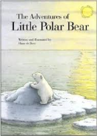 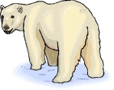

 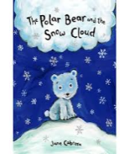

Dear Parents,

Welcome back, we hope you had a wonderful, fun filled Christmas holiday. We would like to give a special welcome to our new children who are starting nursery.

This half term we will be finding out all about Snowy Lands. We are going to have an ‘Snowy lands’ themed role play area with an Arctic Research Station that will encourage the children to explore the Poles, what it’s like to live there, the clothing they. We will also research the wide variety of animals that live there. We will be carrying out some very exciting simple scientific investigations to help the children learn all about Freezing and Melting. They will also be designing, making and testing snow vehicles. If you have any books, pictures or artefacts that are relevant to the topics, we would love to see them, ***please make sure all items sent into school are named.***

Please read your child’s Mini Adventure which is attached to this letter to find out more about what we will be doing.

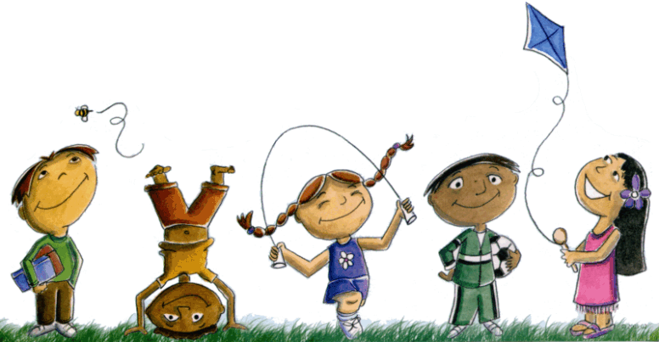Please can parents ensure that all Reception and Year 1 children have their book bag and PE kit in school every day. PE this half term is Dance and will be inside; the children will be in bare feet and do not need trainers. Please can you ensure that your child has the correct PE kit and that it is NAMED!

C:\Users\school\AppData\Local\Microsoft\Windows\Temporary Internet Files\Content.IE5\CINQGGRV\MC900354883[1].wmfThis half term the Nursery children will have their Forest School Outdoor Learning session on a Tuesday morning and will be joined by some of the reception children for some activities. The Reception and Year 1 will continue to take part in their session on a Friday afternoon.

**As the weather is still cold, it’s very important that your child stays warm and to help us, please can you ensure *that your child has the following in school every day:***

* ***a named pair of wellies***
* ***warm, waterproof coat***
* ***a warm pair of socks***
* ***a pair of tracksuit bottoms to change into for outdoor learning***
* ***hat and gloves***

***PLEASE ENSURE ALL ITEMS OF CLOTHING,***

***UNIFORM AND OUTDOOR CLOTHING AND SHOES ARE NAMED!***

If you have any ideas, questions or concerns, please feel free to come and see us, we are always happy to see you. 

**The Explorers’ Team**

**Sophea Pounder, Joanne Murray, Jane White & Sarah Hunter**