Maths | Literacy
Read and write the numbers and number words to twenty.  Count in multiples of 2’s.  I can represent and use number bonds and related subtraction facts, confidently within 10.  Recognise the place value of each digit in a two-digit number (tens, ones).  Use the language of more than, less than (fewer), most and least.  Solve one-step problems with addition and subtraction using concrete objects and pictorial representations including those involving numbers, quantities and measures.  Add and subtract a two-digit number and ones.  Recognise, find and name a half as one of two equal parts of an object, shape or quantity.  Measure accurately using cm’s.  Interpret and construct a simple pictogram. | Read and write all of the first 100 HFW.  Read and write half of the year 1 common exception words.  Segment and blend known sounds to read and write more complex words.  Write about more than one idea and group related information .  Use both familiar and new punctuation correctly, including full stops, capital letters, exclamation marks and question marks.  Write simple stories with a beginning, middle and end.  Read words containing the common suffixes – ing, –ed, and er.  Read words with contractions (for example, I’m, I’ll, we’ll).  Understand and use some conjunctions and connectives.  Re-read books to build up fluency and confidence in word reading, discuss events and link reading to own experiences and other books.  Begin to infer what characters are like from what is being said and done.
Science | Art and Design
Talk about what makes a fair test.  Carry out an investigation to see how far the Snow Mobiles travel, make observations and record results.  Identify and name a variety of common animals that are found in Snowy places and begin to classify them - birds, fish, amphibians, mammals and invertebrates.  Use the language carnivores, herbivores and omnivores when talking about animals that live in Snowy lands. | Explore crayon resist and foil painting to create winter pictures.  Mix primary colours to make secondary using paint and sensory materials.  Use, sort and arrange a combination of materials that are cut, torn and glued and mix materials to create different textures.  Use clay and techniques such as rolling, cutting, moulding and carving to create an animal that lives in Snowy lands.
History / Geography | Design and Technology
Use artefacts, pictures, stories, online sources and databases to find out about famous Polar Explorers.  Recount changes that have occurred in their own lives.  Name and locate the world’s continents and oceans.  Devise a simple map; and use and construct basic symbols in a key. Use simple grid references (A1, B1). | Explore a variety of snow vehicle pictures to identify likes and dislikes and make informed choices for their own snow mobile.  Cut wood using a small hacksaw.  Demonstrate a range of joining techniques to combine materials to strengthen the Snow Mobile.  Suggest improvements to existing designs to improve product.  Join felt using running stitch and learn to knit using a basic stitch.
Computing | Music
Use a range of programmes such as 2 Simple to communicate ideas, work and messages and use 2 Paint to create a front cover page for their story book.  Control when drawings appear and set the pen colour, size and shape.  Control motion by specifying the number of steps to travel, direction and turn.  Use simple databases to record information in areas across the curriculum. | Create a mixture of different sounds (long and short, loud and quiet, high and low) and choose sounds to create an effect.  Listen to a variety of music and use appropriate musical vocabulary to describe it.  Identify some of the different elements of music and how they affect mood and style.  Paint in response to a variety of music.
Religious Education | Physical Development
Listen to, recall, and talk about stories from the Bible with a focus on developing an understanding of some of the Christian values and how they might demonstrate these in their own lives at school and at home.  Link the Bible stories to the concept of ‘Gospel’ or good news.  Recognise that Jesus gives instructions to people about how to behave. | Dance Focus based on Snowy Lands  Move with careful control and coordination  Copy and remember moves and positions.  Link two or more actions to perform a sequence.  Choose movements to communicate a mood, feeling or idea.
Personal, Social and Emotional Development | Spiritual, Moral and Cultural Development
Relate my learning to the Awareness Animals.  Participate positively in all activities.  Be confident when trying new activities that are more challenging.  Be confident to speak in a familiar group and talk about my ideas. | Show I am willing to have a go, take a risk, engage in new experiences and learn by trial and error.  Persevere with an activity when challenges occur.  Reflect on my experiences using pictures and words.  Use my imagination and creativity in my learning.
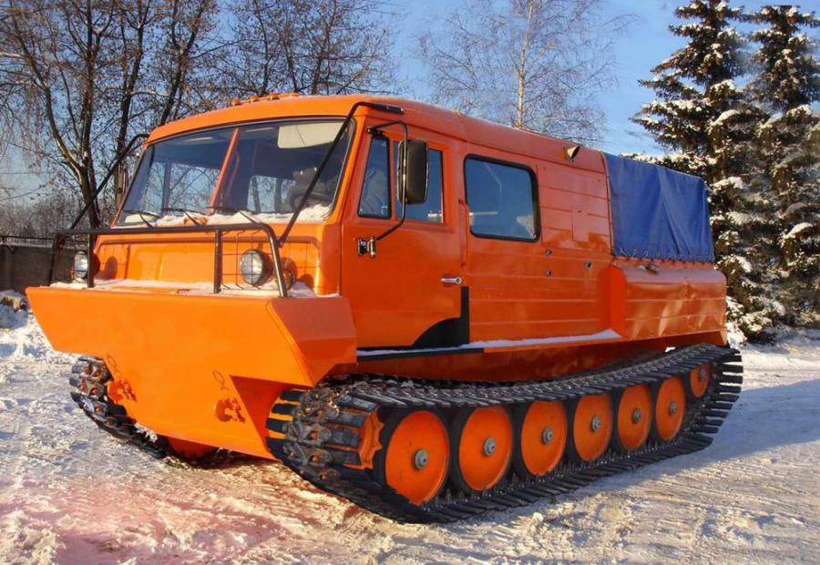
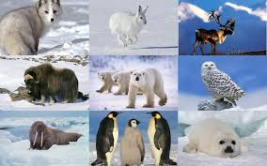
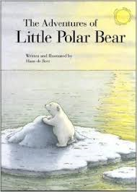
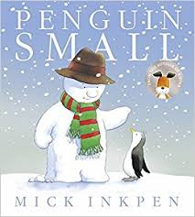
Time to Shine
My Mini Adventure

Literacy & Computing
Write a ‘Snowy Lands’ story with a beginning, middle and an end and create a front cover for the story using 2 Paint.

Science & Maths
Investigate to find how far the Snow Mobiles travel and measure the distance in metres and cm’s.

Art and Design
Create a Snowy Lands picture using a variety of self- chosen mediums and materials.

Design Technology & Maths
Design and make a snow mobile that will move on snowy lands using accurate measuring in cm’s to make the chassis.

Year 1

Snowy Lands
Science & Maths
Investigate to see how far the Snow Mobiles travel using a fair test and measure how far they travel using metres and cms.
Literacy & Computing
Write and publish a simple ‘Snowy Lands’ story book with a beginning, middle and end. Create a front cover for the story using 2 Paint.

