789
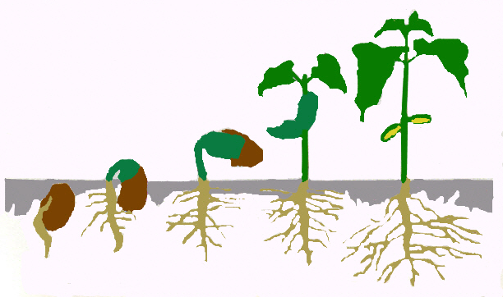
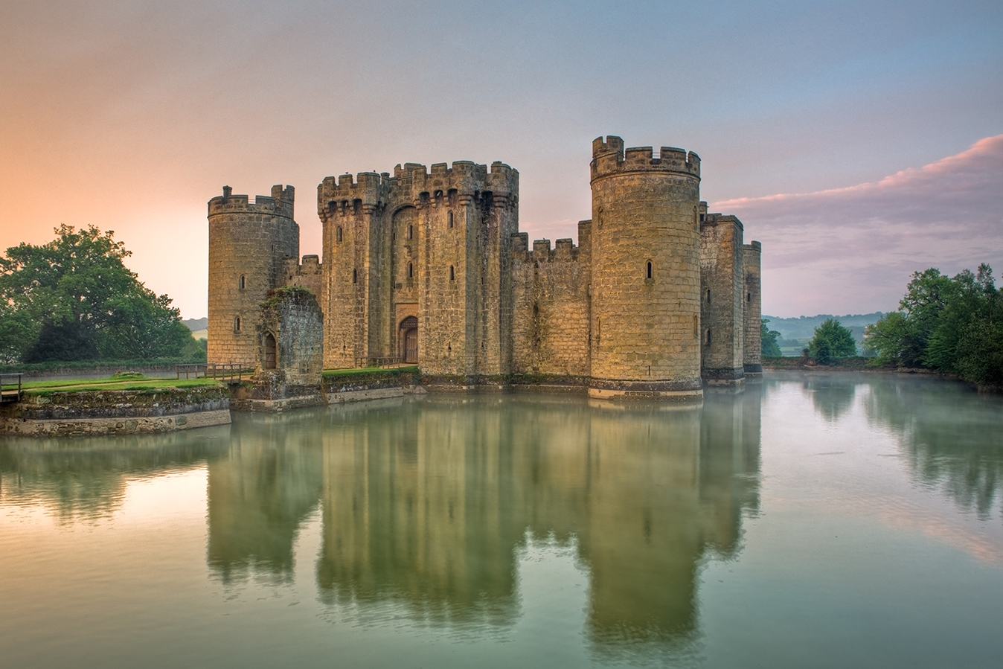
Explorers’ Summer 1 Newsletter
Dear Parents,
We hope you all had a lovely Easter holiday and that the Easter Bunny brought lots of chocolate! We would like to give a special welcome to our ‘New Nursery Starters’ who are joining us.
This week we will start our new Mini Adventure – Castles. We will be researching Castles and how they have changed over time and finding out what castle life was like. We will also be finding out about famous Castles from around the world. We will also have a big focus on ‘Growing, Plants and Trees’ in Science and the children will carry out some research and simple scientific investigations. It would be helpful if you could look at a variety of plants and trees when you are out and about and maybe identify and name some too! The children might want to take photos or draw pictures; we would love to display them in the classroom. The children will also be researching, investigating, using and creating their own musical instruments.
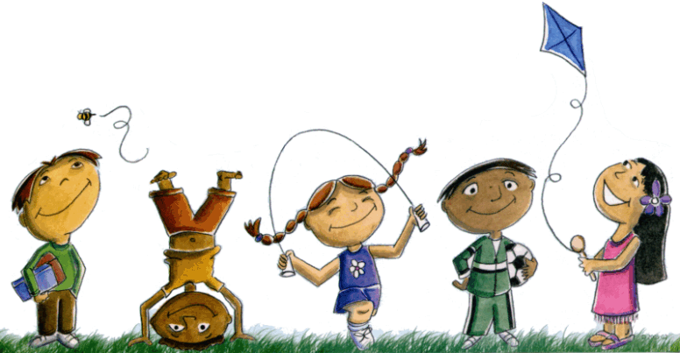 The Nursery children will continue to have an outdoor Physical Development session on Tuesday morning; this session will focus on a range of gross motor skills. The Reception and Year 1 children will continue to have PE on a Monday morning with Mrs Burroughs. Our focus this half term is games skills. Please can you ensure that all the Reception and Year 1 children have their named PE kit in school at all times as we may do PE at other times in addition to this session.
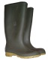 On a Thursday morning the Nursery children will continue to take part in Outdoor/Forest Based Learning. The Reception and Year 1 children will take part in Forest/Outdoor Learning activities on Tuesday and Friday afternoons. Please remember to ensure your child has suitable clothing in school for these sessions.
Homework – Thank you for your ongoing support in helping your child at home. Your support is invaluable and really helps your child. We recommend that in order to support the their learning children in Reception should read their school book at home for at least 5 minutes every day, and then spend a further 5 minutes practising their words and sounds. Once in year 1, children should be reading their books, discussing the text and practising words and sounds for about 15/20 minutes a day. The Year 1 children will continue to get weekly spellings and a weekly maths activity sheet; these are sent home on a Thursday and need to be completed by the following Thursday morning.
Your child’s new Mini Adventure Plan is attached to this letter; we hope you find this informative.
The Explorers’ Team
Sophea Pounder, Karen Fender, Joanne Murray, Jane White & Sarah Hunter

