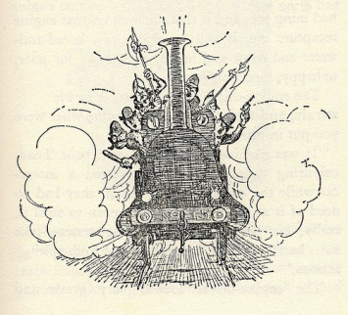
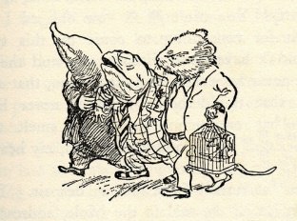
Wind in the Willows

Welcome back! We hope you have had a lovely holiday and are well rested – this is going to be a very busy half term. During this Mini Adventure we are going to be focusing on the contrasting characters from Kenneth Grahame’s classic novel Wind in the Willows. From the peace of the river bank to the maniacal misadventures of Toad, it is a story the children are sure to fall in love with. This will lead us to investigating local wildlife and the river.
Please find the attached Mini-Adventure, for further curriculum information.
PE and Swimming
On Mondays, Mrs Burroughs will be leading the children in tennis this half term. Please ensure that children have their full PE kit in school by next Monday, this may include jogging bottoms for colder days. Swimming continues in its usual Thursday afternoon slot.
Ford Castle
At the end of the half term, children in Y3 are heading off to Ford Castle. A date for a meeting with parents regarding the trip will be sent out this week. Parents are also reminded that the children will present their Ford Castle assembly on Friday 26th May at 9:00am.
SATS
It’s that time of the year again. This year, the Year 2 children will have two reading papers and two mathematics papers. We look to complete these in the second last week of this half term but aim to keep it low-key and stress-free. Results of SATS will be included in your child’s end of year report. Remember, SATs contribute to but do not dictate the class teacher’s final assessment of your child’s attainment at the end of KS1.

As always, if there is anything that you wish to discuss or query, please contact Mr Long to make an appointment.
Many thanks
Richard Pearson and Vanessa Robshaw

